## **Authorize.Net Configuration**

To configure your integration, register for an account on [Authorize.Net](https://account.authorize.net/activation/Boarding/Signup) or login to your existing account. Navigate to <AUTH.NET PAGE HERE> to obtain your Api Login ID and Transaction Key.

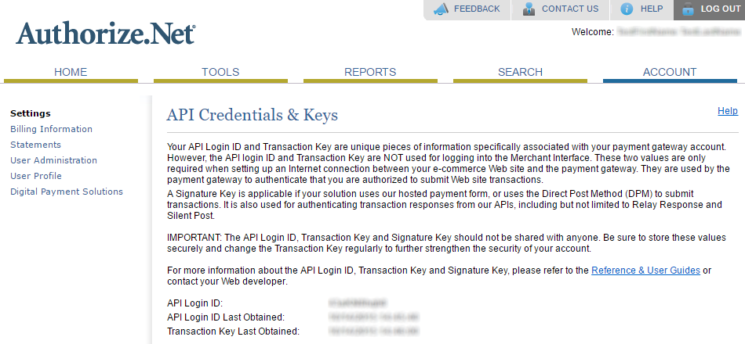

Once you’ve obtained these credentials, navigate to the [Dashboard Integrations](https://dashboard.ordercloud.io/integrations) page within OrderCloud.io and select Authorize.Net.

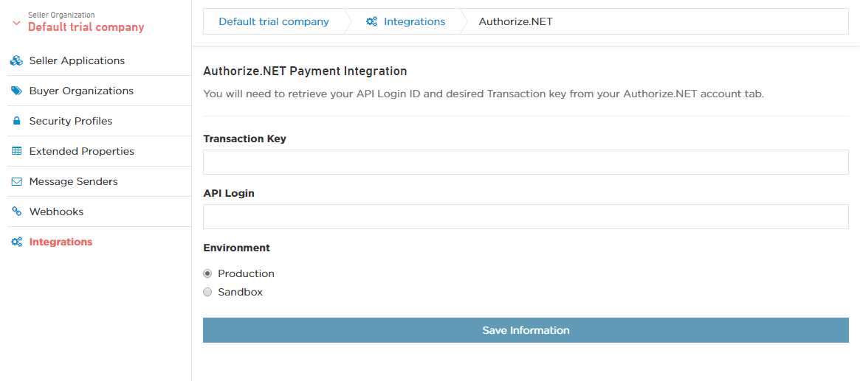

Fill in your credentials from above in the form, select which environment within Authorize.Net you’ll be working in, then click Save Information.